Assignment 04 -FML

Chathurani Ekanayake

2023-03-18

install.packages(“factoextra”) install.packages(“flexclust”)

library(tidyverse)

## ── Attaching packages ─────────────────────────────────────── tidyverse 1.3.2 ──  
## ✔ ggplot2 3.4.0 ✔ purrr 1.0.1   
## ✔ tibble 3.1.8 ✔ dplyr 1.0.10  
## ✔ tidyr 1.3.0 ✔ stringr 1.5.0   
## ✔ readr 2.1.3 ✔ forcats 0.5.2   
## ── Conflicts ────────────────────────────────────────── tidyverse_conflicts() ──  
## ✖ dplyr::filter() masks stats::filter()  
## ✖ dplyr::lag() masks stats::lag()

library(factoextra)

## Welcome! Want to learn more? See two factoextra-related books at https://goo.gl/ve3WBa

library(ISLR)  
library(flexclust)

## Loading required package: grid  
## Loading required package: lattice  
## Loading required package: modeltools  
## Loading required package: stats4

library(tinytex)  
library(cluster)  
library(FactoMineR)  
library(ggcorrplot)  
library(NbClust)

library(readxl)  
Pharmaceuticals <- read_excel("F:/1st sem/ML/Assignment 04/Pharmaceuticals.xlsx")  
View(Pharmaceuticals)

# a) Use only the numerical variables (1 to 9) to cluster the 21 firms. Justify the various choices made in conducting the cluster analysis, such as weights for different variables, the specific clustering algorithm(s) used, the number of clusters formed, and so on.

t(t(names(Pharmaceuticals)))

## [,1]   
## [1,] "Symbol"   
## [2,] "Name"   
## [3,] "Market_Cap"   
## [4,] "Beta"   
## [5,] "PE_Ratio"   
## [6,] "ROE"   
## [7,] "ROA"   
## [8,] "Asset_Turnover"   
## [9,] "Leverage"   
## [10,] "Rev_Growth"   
## [11,] "Net_Profit_Margin"   
## [12,] "Median_Recommendation"  
## [13,] "Location"   
## [14,] "Exchange"

# Selecting numerical variables   
df <- Pharmaceuticals[,c(3:11)]  
t(t(names(df)))

## [,1]   
## [1,] "Market_Cap"   
## [2,] "Beta"   
## [3,] "PE_Ratio"   
## [4,] "ROE"   
## [5,] "ROA"   
## [6,] "Asset_Turnover"   
## [7,] "Leverage"   
## [8,] "Rev_Growth"   
## [9,] "Net_Profit_Margin"

# Normalizing the data   
df1 <- scale(df)  
distance <- get_dist(df1)  
fviz_dist(distance,)

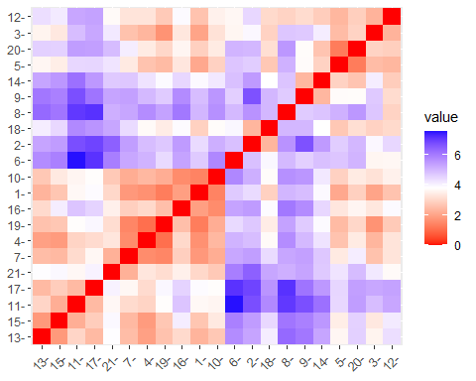

# determine the optimal value of clustering using elbow method & silhouette index.  
set.seed(10)  
wss <- vector()  
for(i in 1:10) wss[i]<- sum(kmeans(df1,i)$withinss)  
plot(1:10, wss, type="b", main=paste("cluster of Companies"), xlab = "number of clusters k", ylab="wss")

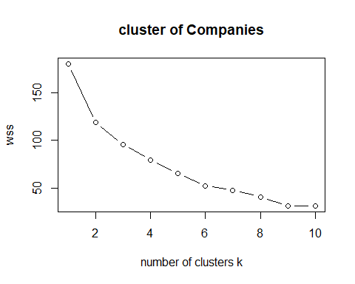

# According to the above graph it shows the optimal number of clusters is 6  
fviz_nbclust(df1, stats::kmeans, method = "silhouette")

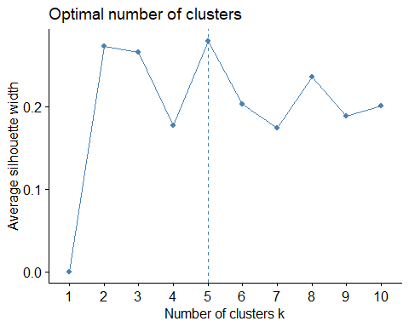

#According to the above plot it shows the optimal number of cluster is 5   
  
# Perform K-means clustering with k= 4 to 7  
k4<-kmeans(df1, centers=4, nstart=25)  
k5<-kmeans(df1, centers=5, nstart=25)  
k6<-kmeans(df1, centers=6, nstart=25)  
k7<-kmeans(df1, centers=7, nstart=25)  
  
p1<-fviz_cluster(k4,geom="point", data=df1)+ggtitle("k=4")  
p2<-fviz_cluster(k5,geom="point", data=df1)+ggtitle("k=5")  
p3<-fviz_cluster(k6,geom="point", data=df1)+ggtitle("k=6")  
p4<-fviz_cluster(k7,geom="point", data=df1)+ggtitle("k=7")  
  
library(gridExtra)

##   
## Attaching package: 'gridExtra'

## The following object is masked from 'package:dplyr':  
##   
## combine

grid.arrange(p1,p2,p3,p4,nrow=2)

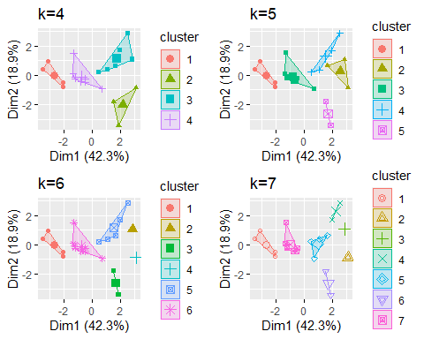

# Based on the above calculations Select K=5 as the optimal number of clusters

# b) Interpret the clusters with respect to the numerical variables used in forming the clusters.

# Plot K=5 cluster indicating with the index number   
k5 <-kmeans(df1,centers = 5, nstart = 25)  
  
# Add cluster labels to the original data set.  
Pharmaceuticals$cluster <- k5$cluster  
print(Pharmaceuticals)

## # A tibble: 21 × 15  
## Symbol Name Marke…¹ Beta PE_Ra…² ROE ROA Asset…³ Lever…⁴ Rev_G…⁵  
## <chr> <chr> <dbl> <dbl> <dbl> <dbl> <dbl> <dbl> <dbl> <dbl>  
## 1 ABT Abbott Labo… 68.4 0.32 24.7 26.4 11.8 0.7 0.42 7.54  
## 2 AGN Allergan, I… 7.58 0.41 82.5 12.9 5.5 0.9 0.6 9.16  
## 3 AHM Amersham plc 6.3 0.46 20.7 14.9 7.8 0.9 0.27 7.05  
## 4 AZN AstraZeneca… 67.6 0.52 21.5 27.4 15.4 0.9 0 15   
## 5 AVE Aventis 47.2 0.32 20.1 21.8 7.5 0.6 0.34 26.8   
## 6 BAY Bayer AG 16.9 1.11 27.9 3.9 1.4 0.6 0 -3.17  
## 7 BMY Bristol-Mye… 51.3 0.5 13.9 34.8 15.1 0.9 0.57 2.7   
## 8 CHTT Chattem, Inc 0.41 0.85 26 24.1 4.3 0.6 3.51 6.38  
## 9 ELN Elan Corpor… 0.78 1.08 3.6 15.1 5.1 0.3 1.07 34.2   
## 10 LLY Eli Lilly a… 73.8 0.18 27.9 31 13.5 0.6 0.53 6.21  
## # … with 11 more rows, 5 more variables: Net_Profit_Margin <dbl>,  
## # Median_Recommendation <chr>, Location <chr>, Exchange <chr>, cluster <int>,  
## # and abbreviated variable names ¹​Market_Cap, ²​PE_Ratio, ³​Asset_Turnover,  
## # ⁴​Leverage, ⁵​Rev_Growth

# Calculate the mean values,centers and size of each numerical variable for each cluster   
aggregate(Pharmaceuticals[,3:11], by=list(Pharmaceuticals$cluster),mean)

## Group.1 Market_Cap Beta PE_Ratio ROE ROA Asset_Turnover  
## 1 1 31.910000 0.40500 69.5000 13.20000 5.600000 0.7500  
## 2 2 6.636667 0.87000 24.6000 16.46667 4.166667 0.6000  
## 3 3 157.017500 0.48000 22.2250 44.42500 17.700000 0.9500  
## 4 4 13.100000 0.59750 17.6750 14.57500 6.200000 0.4250  
## 5 5 55.810000 0.41375 20.2875 28.73750 12.687500 0.7375  
## Leverage Rev_Growth Net_Profit_Margin  
## 1 0.475000 12.080000 6.400000  
## 2 1.653333 5.733333 7.033333  
## 3 0.220000 18.532500 19.575000  
## 4 0.635000 30.142500 15.650000  
## 5 0.371250 5.591250 19.350000

k5$centers

## Market_Cap Beta PE_Ratio ROE ROA Asset_Turnover  
## 1 -0.43925134 -0.4701800 2.70002464 -0.8349525 -0.9234951 0.2306328  
## 2 -0.87051511 1.3409869 -0.05284434 -0.6184015 -1.1928478 -0.4612656  
## 3 1.69558112 -0.1780563 -0.19845823 1.2349879 1.3503431 1.1531640  
## 4 -0.76022489 0.2796041 -0.47742380 -0.7438022 -0.8107428 -1.2684804  
## 5 -0.03142211 -0.4360989 -0.31724852 0.1950459 0.4083915 0.1729746  
## Leverage Rev_Growth Net_Profit_Margin  
## 1 -0.14170336 -0.1168459 -1.416514761  
## 2 1.36644699 -0.6912914 -1.320000179  
## 3 -0.46807818 0.4671788 0.591242521  
## 4 0.06308085 1.5180158 -0.006893899  
## 5 -0.27449312 -0.7041516 0.556954446

k5$size

## [1] 2 3 4 4 8

# Cluster 1 - This cluster contains four companies. 11. GlaxoSmithKline plc, 13. Johnson & Johnson, 15. Merck & Co., 17. Inc., Pfizer Inc   
# According to the above calculations, this cluster has the highest market capital, highest Return On Equity (ROE), highest Return On Asset (ROA), highest value of Asset Turnover and highest Net Profit Margin.Therefore this cluster represents large and stable pharmaceutical companies with high profitability and low financial risk.   
  
# Cluster 2 - This cluster contains three companies. 6.Bayer AG, 8.Chattem, Inc & 12.IVAX Corporation.   
# According to the above calculations, this cluster has the lowest market capital,highest beta,lowest Return on Asset (ROA),but it has highest leverage. Comparatively this cluster has a lower net profit margin. According to that, this cluster contains small risky pharmaceutical companies with low profitability but high growth potential.  
  
# Cluster 3 - This cluster contains eight companies.1.Abbott Laboratories, 3.Amersham plc, 4.AstraZeneca PLC, 7.Bristol-Myers Squibb Company, 10.Eli Lilly and Company, 16.Novartis AG, 19.Schering-Plough Corporation, 21.Wyeth  
# According to the above calculations, this cluster has moderate values for all numerical variables and it has the lowest rev growth rate. Therefore this cluster can be identifies as group of pharmaceutical companies with moderate profitability and financial risk.  
  
# Cluster 4 - This cluster contains four companies. 5.Aventis, 9.Elan Corporation, plc, 14.Medicis Pharmaceutical Corporation, 20.Medicis Pharmaceutical Corporation  
# According to the above calculations, this cluster has the lowest market capital, lowest Profit Earning (PE) ratio, lowest asset turnover with highest revenue growth.Therefore this cluster can be identifies as high-growth, high efficiency and profitable market with low financial stability.   
  
# Cluster 5 - This cluster contains two companies. 2.Allergan, Inc., 18.Pharmacia Corporation  
# According to the above calculations, this cluster has the lowest beta value, Highest Profit Earning (PE) ratio, lowest Return On Investment Ratio (ROE) and lowest net profit margin. Therefore this cluster contains pharmaceutical companies with high growth potential but low profitability.

# C) Is there a pattern in the clusters with respect to the numerical variables (10 to 12)? (those not used in forming the clusters)

Pharmaceuticals$cluster <- k5$cluster  
  
# Answer:   
# According to the above table it is hard to find a direct relationship of Median_Recommendation & Exchange with formed clusters. But some locations can be find only in specific clusters.   
  
# According to that, UK pharmaceutical companies can be seen only in cluster one or three. Therefore, UK companies are out performers or moderate companies.   
# Germany can be find only in the second cluster, so Germany can be identified as growing company with higher risk.   
# Switzerland comes only in the third cluster, so it is in the moderate level.   
# France and Ireland are coming under the fourth cluster. So, those two countries are efficient as well as risky.   
# Canada coming under the fifth cluster. Therefore Canada can be identify as an nonperforming country but it is growth driven.

# D) Provide an appropriate name for each cluster using any or all of the variables in the dataset

# Cluster 1: "Stable Profit Leaders" - This cluster represents large and stable pharmaceutical companies ,high market capital with high profitability and low financial risk.  
  
# Cluster 2: "High Growth Risk Takers" - This cluster represents small and risky pharmaceutical companies with low profitability but high growth potential.  
  
# Cluster 3: "Moderate Performers" - This cluster represents pharmaceutical companies with moderate profitability and financial risk.  
  
# Cluster 4: "Efficient but Risky" - This cluster represents pharmaceutical companies with high efficiency and profitability, but low financial stability.  
  
# Cluster 5: "Growth-Driven Under performers" - This cluster represents pharmaceutical companies with high growth potential but low profitability.